**CS443 – Lab 5**

**Question 1:**

Use extended hashing technique to insert the employees in which their corresponding binary Empl_IDs are shown below. Assume you can have two employees per block. Show the depth of both global and local directories. The bits should be considered from left to right as shown in the lecture..

**00001, 10000, 10100, 00111, 11011, 11101, 10010, 01111, 10101**

Insert 00001, Insert 10000, Insert 10100, Insert 00111

Insert 11011, Insert 11101

Continued…

Insert 10010, Insert 01111, Insert 10101

**Question 2:**

Consider the following records of question 1: (Again Digits should be considered from left to right)

**00001, 10000, 10100, 00111, 11011, 11101, 10010, 01111, 10101**

Load the records into files using Dynamic Hashing Scheme. You can put two records per block. Show the directory at each step, and the global and local depths.

Insert 00001, Insert 10000, Insert 10100, Insert 00111

Continued..

Insert 11011, Insert 11101

Insert 10010

Insert 01111, Insert 10101

**Question 3:**

Insert the following into B+ tree of order **3**. Show your work step by step with proper illustration of pointers as shown in pages 47-54 in multi-way trees lecture

**90, 22, 27, 24, 28, 20, 51, 63, 8, 80, 15, 71, 35, 55**

Insert 90

Insert 22

Insert 27

Insert 24

Insert 28

Insert 20

Insert 51

Insert 63

Insert 8

Insert 15

Insert 71

Insert 35

Insert 55

**Question 4:**

Insert the following into B_tree of order **3**. Show your work step by step with proper illustration of pointers as shown in pages 47-54 in multi-way trees lecture

**2, 99, 9, 71, 16, 11, 15, 13, 91, 92, 94**

🡪

Continued..

🡪

🡪

**Question 5:**

Consider the following B-tree.

a) Redraw the tree after deleting 14.

b) Again, redraw the tree after deleting 15.

c) Again, redraw the tree after deleting 25.

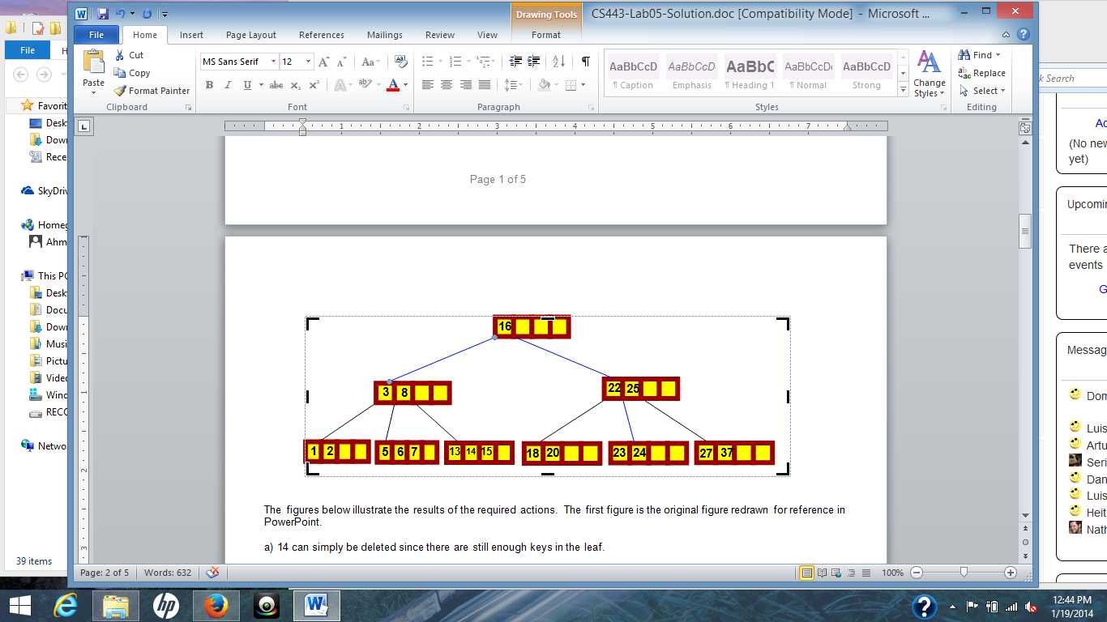

1. Diagram

   Description automatically generated
2. Diagram

   Description automatically generated
3. Diagram

   Description automatically generated with medium confidence

**Question 6:**

Consider the following B+ tree:

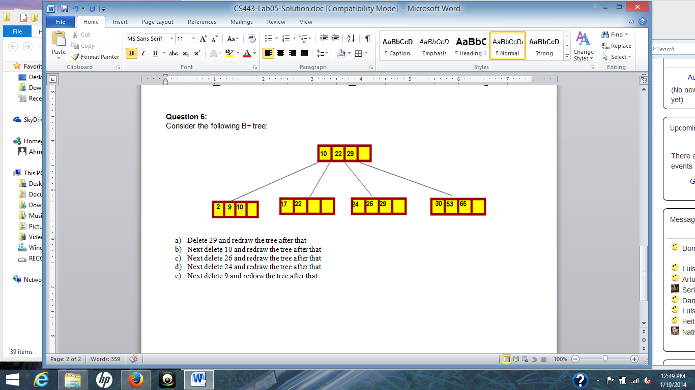

1. Delete 29 and redraw the tree after that

1. Next delete 10 and redraw the tree after that

1. Next delete 26 and redraw the tree after that

Continued..

1. Next delete 24 and redraw the tree after that

1. Next delete 9 and redraw the tree after that

